**Port Performance Dashboard**

Analysis and visualizations from the Transportation Research Group at Washington State University

Data Analyzed:

2B AIS messages 70 Ports 811 Docks

Default Visualizations

[date slider]

[metric dropdown] [port dropdown]

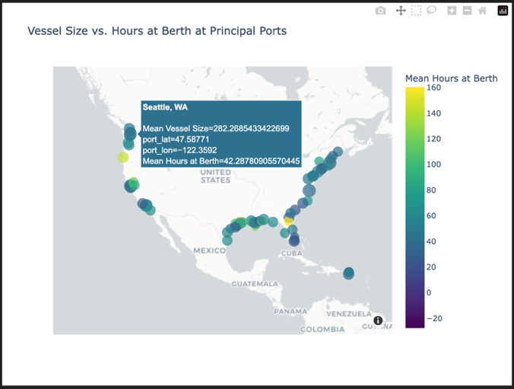

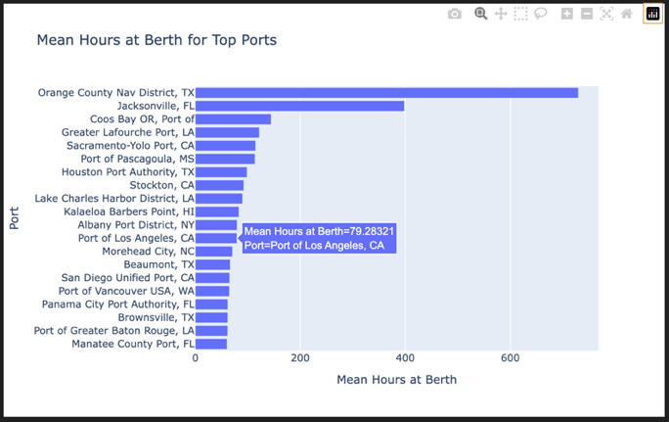

**Second Page – Multi-metric Port Drill-down**

[port drop down] [dock drop down (default all docks, list of other docks at that port)]

[date slider] [vessel size slider] [vessel type (container, bulk)]

[dock type(container, bulk, ro/ro)]

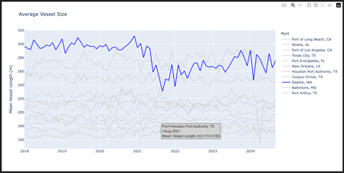 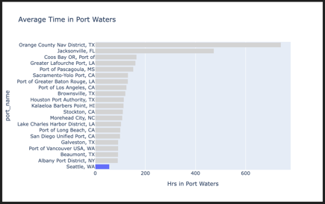

[size dropdown] [color dropdown] [size dropdown] [color dropdown]

[metric dropdown] [metric dropdown]

[metric dropdown] [metric dropdown]

**Next Page - Custom Visualizations**

**User Selections**:

* Date Range (slider)
* Port (check box)
  + No selection keeps port/national level
  + Selection drills down to dock level
* Visualization Type
  + Scatter Map, Line, Bar
* Group Variable
  + Port, Dock, Time (month, year, etc)
    - Depends on visualization type
* Metric (check box)
  + Hrs at berth, berth turnover, time in port waters, etc
* Statistic (check box)
  + Mean, median, max, count